PGRKAM – User Analytics and Job Recommender System
2nd Rohit S
Student
B.Tech CSE AIML(of Aff.)
Presidency Unviersity (of Aff.)
Bengaluru, India
rohit.20211cai0150@presidencyuniversity.in

3rd Syed Azeem
Student
B.Tech CSE AIML(of Aff.)
Presidency Unviersity(of Aff.)
Bengaluru, India
syed.20211cai0182@presidencyuniversity.in

1st Dr. Selvaganesh R
Assistant Professor Computer Science Engineering (of Aff.)
Presidency University (of Aff.)
Bengaluru, India
selvaganesh@presidencyuniversity.in

ABSTRACT
The Punjab Ghar Ghar Rozgar and Karobar Mission (PGRKAM) is an important government program tackling unemployment by bridging job seekers with opportunities. In spite of having a huge user base, its performance is hindered due to the lack of data analytics-based inputs and tailored suggestions, thus leading to bad user experience and a mere 6.7% success rate. This work suggests an integrated analytics platform and a hybrid recommendation engine blending content-based filtering, collaborative filtering, and optimization using Genetic Algorithm. Based on 50,000 user data, 2,000 job ads, and 96,179 application data, we identify key trends and show how the suggested system enhances efficiency and employment rates.
Keywords— (recommender systems, data analytics, job portal, collaborative filtering, content-based filtering, hybrid models, genetic algorithm, public employment.)

INTRODUCTION

Over the last few years, online employment platforms have emerged as vital tools for combating unemployment and underemployment. International platforms like LinkedIn, Indeed, and Glassdoor have revolutionized the process of job seeker–employer matching through the use of sophisticated analytics, machine learning-based personalization, and mass processing of data. These platforms extend beyond functioning as job boards; they offer career information, skill gap analysis, and personalized job suggestion, thus improving user engagement as well as recruitment efficiency.

Conversely, most government-sponsored employment websites have not managed to match the leaps made in these areas. While they do manage to attain scale and inclusivity, ensuring equal access to job opportunities across socio-economic groups, they frequently fail to have the advanced recommendation engines and analytics dashboards their private sector counterparts use. This leaves a gap: government

portals usually manage wide reach but make available a generic one-size-fits-all experience to their audience.

The Punjab Ghar Ghar Rozgar and Karobar Mission (PGRKAM) is a flagship program of the Punjab Government designed to be the central platform for job seekers and employers. With a fast-growing list of users, the site has great potential to de-bottleneck the recruitment process in the state. Yet, at present, it shows some great limitations. Recruiters present job seekers with lengthy, unsorted lists of openings without targeting, which requires them to physically sort through hundreds of job listings. Not only does this raise the effort and time needed to find fit jobs but also aids in mass application misfitting—users applying to openings for which they are neither qualified nor interested.

The lack of analytics dashboards worsens the issue. Administrators gain limited insights into:
- Which of the acquisition channels (referrals, advertising, word of mouth) work best.
- Which categories of skills are in greatest demand.
- At what point in the application process customers drop out.
Without this transparency, it becomes almost impossible to identify inefficiencies or to target strategies for outreach, training, and employer engagement.

The inefficiency of the existing system can be best explained through the dataset analysis: out of more than 96,000 job applications, just 6.7% lead to successful selection and a whopping 93.3% get rejected. This low percentage in success points to systemic inefficiency. For the job seekers, it means frustration, wasted time, and loss of confidence in the platform. For the recruiters, it means noise—a deluge of redundant applications that have to be hand-filtered. To policymakers, it creates questions regarding the efficacy of public funds spent on the platform. Compared to their international counterparts, global job portals have much more favorable success rates, due in part to more advanced algorithms for personalization that lead searchers to suitable opportunities.

Closing this gap involves reimagining the PGRKAM platform as something beyond a job posting repository. Rather, it should become a data-driven employment ecosystem that serves job seekers, employers, and administrators concurrently. The cornerstone of such a shift is in two interconnected innovations:
- An Integrated Analytics Tool
To enable administrators to gain actionable insights into user profiles, usage patterns, skill demand, and acquisition effectiveness.
To facilitate real-time tracking of the platform's performance, detect bottlenecks, and facilitate evidence-based policy-making.

- A Hybrid Job Recommender System
To offer job seekers ranked, personalized job recommendations based on their skills, qualifications, and interests.
To use both content-based filtering (skills-job matching) and collaborative filtering (peer behavior) and optimize using a Genetic Algorithm to maximally maximize success probability.

Collectively, these innovations can take PGRKAM from a passive bulletin board to a dynamic, smart employment platform. By integrating data analytics and machine learning, the system not only will enhance user experience but also directly help achieve better job placement rates, higher recruiter satisfaction, and more effective government resource utilization.

RELATED WORK

The domain of recommender systems is well-recommender systems are now a pillar of online platforms, with far-reaching applications in e-commerce, entertainment, education, tourism, and employment. Their main role is to mitigate information overload by offering users a selected set of options most pertinent to their interests or requirements. In the job market, recommender systems are especially useful since job applicants not only have to navigate an enormous number of ads but also are under high stakes since applications for jobs have tangible repercussions for their well-being and professional development.

Early job recommendation techniques were based on keyword matching. These systems tried to find equivalence of words in user profiles and job descriptions. Simple as they were, such systems were brittle, not respecting semantic equivalences (e.g., "software engineer" and "backend developer") and tending to deliver irrelevant or redundant answers. When the weakness of keyword matching became obvious, researchers began to explore more advanced algorithms.

- Content-Based Filtering Approaches

Content-based filtering (CBF) systems suggest items based on matching item characteristics with user profiles. For job recommendations, this generally involves pitting a candidate's qualifications, education, and experience against the qualifications listed in job advertisements.
- Rahim and Basheer [2] proposed a multi-level personalized career recommender system that included aptitude-based profiling, demonstrating how hierarchical models may enhance the accuracy of career advice.
- Singla and Verma [3] used semantic embeddings and machine learning to match user profiles to job postings, solving the terminology mismatch issue. Their solution reflects the need to transcend mere keyword similarity to embed semantic meaning in skill-job relations.
Although content-based approaches are very good at exactly matching explicit qualifications, they have the drawback of over-specialization. The users are only suggested jobs identical to what they have already applied for or mentioned in their skills, and so discover fewer new opportunities.

- Collaborative Filtering Approaches

Collaborative Filtering (CF) is based on the belief of "users who acted in a similar way in the past will act in a similar way in the future." CF does not rely on job characteristics alone but learns from user actions—applications received, viewed jobs, or even implicit feedback such as duration on postings.
- Deshpande and Karypis [17] showed the effectiveness of item-based collaborative filtering, in which job advertisements are suggested with similarities to other advertisements users have bid on.
- Resnick et al. [19] invented user-based collaborative filtering, initially in Usenet news filtering, which later influenced employment platform applications.
- Davidson et al. [13] demonstrated how CF was scaled to millions of users in YouTube's video recommendation system, a use case that illustrates its excellence in finding new and diverse content.
In spite of its merits, CF is plagued with two primary issues:
- Cold Start Problem – when new users or new jobs do not have any historical data, CF is unable to make good recommendations.
- Data Sparsity – in big systems such as PGRKAM, in which each user requests only a tiny fraction of jobs, the user-job interaction matrix is sparse, constraining CF's precision.

- Hybrid Models

To overcome the limitation of single methods, hybrid recommender systems integrate two or more approaches.
- Burke [20] carried out an extensive survey of hybrid models and showed their capacity to surpass single-technique systems by balancing accuracy, novelty, and diversity.
- Amatriain and Basilico [16], in the case study of Netflix, explained how hybrid approaches, combining CF with contextual cues, were fundamental to enhancing movie suggestions.
- Çelik Ertuğrul [4] presented a systematic review of recommender systems for jobs, highlighting the most promising approach as hybridization for the employment market.
Hybrid methods may come in several flavours: weighted (assigning relative weights to CF vs. CBF), switching (picking one according to circumstance), or cascaded (applying one to refine another's outcomes). For PGRKAM, a weighted hybrid model is preferred because it supports explicit skill matching integration with behavioural patterns, dynamically adapted by optimization methods.

- Optimization-Based Recommenders

Recent research has delved into optimization algorithms to optimize recommender systems.
- Mashayekhi et al. [8] applied optimal transport methods to regulate congestion in job recommendations to distribute fairly among candidates.
- Behar et al. [7] developed a graph-based model of recommendation (TIMBRE) that worked effectively on recruiter-job-seeker relationships in multi-graph heterogeneous networks.
- Zhao et al. [5] shed light on the revolutionary work of Large Language Models (LLMs), which can improve recommendation by realizing subtle, unstructured job postings and resumes.
Our methodology borrows ideas from these papers by incorporating a Genetic Algorithm (GA) for parameter tuning. The GA adaptively modifies the weights given to content-based and collaborative filtering elements so that recommendations are constantly optimized to achieve maximum application success rates.

- Analytics in Recommendation Systems
In parallel with recommendation algorithms, analytics platforms offer insights into user behavior, engagement, and retention.
- Davidson et al. [13] and Amatriain & Basilico [16] both stressed the need for feedback loops between recommendations and analytics. Without analytics, systems will not be able to evolve according to changing user requirements.
- Steck [14] advocated incorporating diversity and fairness metrics in the evaluation, which is particularly important for government job portals where equal access needs to be provided.
- Hassan et al. [10] suggested personality-aware recommender systems within education, which was based significantly on user characteristics analytics—demonstrating the promise of using similar methods in employment.
Analytics for PGRKAM are not just an assistive tool but a core element of the recommender pipeline. See referral channels, demographic splits, and engagement funnels to enhance system design and achieve inclusivity.

Summary and Contribution of This Work
The discussed literature illustrates that:
- Content-based filtering has accurate matches but no novelty.
- Collaborative filtering has the ability to reveal new opportunities but fails with sparsity and cold-start.
- Hybrid approaches always perform better than single methods, particularly in the intricate domains such as employment.
- Optimization and analytics frameworks are needed to render recommender systems adaptive and resilient in real-world applications.

Based on these findings, our work makes two contributions:
- Development of a hybrid recommender system that integrates content-based and collaborative filtering with optimization using Genetic Algorithms.
- An analytics dashboard for administrators that can provide real-time tracking of user behavior, skill demand, and application outcomes.
This two-pronged approach enables PGRKAM to grow as a data-driven employment platform that not only enhances user experience but also offers actionable insights for policymakers and recruiters.

DATASET AND EXPLORATORY ANALYSIS

In order to assess the performance and limitations of the PGRKAM platform, we performed exploratory analysis upon a dataset containing 50,000 registered users, 2,000 job adverts, and 96,179 applications. The dataset contains a rich picture of the prevailing employment landscape in Punjab and enables us to determine bottlenecks, imbalances, and inefficiencies that spur the formulation of our suggested system.

- Geographic Distribution of Users

The user locations analysis reveals that the population is highly concentrated in urban and semi-urban areas like Chandigarh, Patiala, and Bathinda (Fig. 1). Although this reflects robust metropolitan adoption, it also points to uneven coverage. Rural districts, though with extensive populations of unemployed youth seeking jobs, are underrepresented.
This imbalance has a number of implications:
- Awareness Gap: Numerous rural job seekers might not be aware of the platform, and instead, they depend upon word-of-mouth networks for jobs.
- Digital Divide: Insufficient access to smartphones, internet connectivity, and digital literacy constraints rural involvement.
- Policy Insight: Special outreach initiatives (e.g., mobile job fairs, village-level awareness programs) can bridge this gap.
The geographic distribution, therefore, indicates that PGRKAM is effective in urban reach, but access is unequal.

- User Acquisition Channels

The platform growth is mostly led by organic and community-driven channels. From Fig. 2, the three strongest sources of new users are referrals (16.8%), word of mouth (16.7%), and the official government website (16.7%). Much less significant are paid channels like Facebook advertising and newspaper ads.
A number of insights can be gleaned from this trend:
- Trust Factor: Users will sign up more through trusted word-of-mouth recommendations or government endorsement than through advertising.
- Cost Efficiency: Organic channels being the most prominent, excessive spend on digital advertising might be uneconomical.
- Engagement Strategy: Building outreach through community-focused channels, such as colleges, training institutes, and local job centers, could be more engagable than increasing ad spend.
This supports the necessity of an analytics dashboard to regularly track acquisition efficiency to make sure resources are being directed toward the most effective channels.

- Educational Background of Users

The data shows that PGRKAM has a broad range of educational qualifications. As shown in Fig. 3, the majority of groups include users with BSc degrees (12.6%), diplomas (12.6%), and high school qualifications (12.5%). BA, BTech, and postgraduate students are also major segments.
Key observations include
- Skill Gap Identification: High numbers of applicants possess qualifications that are not clearly aligned to high-demand occupations (e.g., the generic science degree not followed by industry certifications).
- Vocational Potential: Diploma graduates form a large segment that might be helped by focused industry-aligned training schemes (manufacturing, IT support, electrical).
- Inclusivity Challenge: High-school-level applicants might struggle to compete with degree graduates unless vocational and entry-level positions are more exposed.
From a policy standpoint, the skill distribution emphasizes diversified work opportunities as well as individualized suggestions that match both high-skill and low-skill applicants.

We analyzed the supply and demand of skills as a main point of analysis to compare what individuals place in their profiles with what employers require in ads.
- User Skills (Supply): Referring to Fig. 4, the most prevalent skills among candidates are Python, Java, SQL, and communication skills. This reflects a widespread availability of candidates with computer programming and IT skills, as well as overall soft skills.
- Employer Demands (Demand): Fig. 5 indicates that employers demand technical skills like Python, Java, SQL, React, and AWS as well.

Upon initial observation, the intersection of supply and demand seems to be good. Closer examination, however, uncovers problems in the system:
- Oversaturation: With thousands of users having Python and Java in their job listings, competition for IT is out of proportion. Individual probabilities of success decrease.
- Skill Gaps: While more employers insist on advanced skills (e.g., cloud platforms, DevOps, data analytics), these tend to show up less often in user profiles.
- Soft Skills Mismatch: Although most users cite communication skills, employers are seeking domain skills (e.g., sales, customer service, supply chain management).

The skills analysis, therefore, emphasizes the need for recommendation algorithms more nuanced than mere matching. The platform should not only counteract supply-demand forces but also emphasize untapped roles and steer users to upskilling paths.
- Application Outcomes

The most concerning finding comes from analysing the 96,179 job applications. As shown in Fig. 6, 93.3% of all applications were rejected, with only 6.7% selected.
This alarmingly low success rate can be attributed to multiple factors:
- Inefficient Filtering: Without personalization, users often apply indiscriminately to many jobs, leading to a flood of unsuitable applications.
- User Behaviour: Lack of guidance encourages a “spray-and-pray” approach, where candidates apply to jobs regardless of fit.
- Overload of Recruiter: Large numbers of irrelevant applications overwhelm employers, making it increasingly difficult to select qualified candidates.
- Structural Imbalance: Over-supply in IT-related positions compared to under-application in new areas decreases overall efficiency.

To put this into perspective, international job portals like LinkedIn experience much greater conversion rates, estimated at 20–30% shortlisting rates for suitably matched candidates. This disparity further emphasizes the need to add intelligent recommendation systems to PGRKAM.

- Implications of EDA for System Design

The results of exploratory analysis identify systemic inefficiencies and inform the design of our solution:
- Low Rural Participation → Call for targeted outreach and incorporation.
- Organic Acquisition Dominance → Enhance trust-based and community-based onboarding.
- Educational Diversity → Personalization needed to cater to graduates and vocational applicants alike.
- Skill Oversaturation → Algorithm needs to balance competition and emphasize niche prospects.
- Low Application Success Rate → Justifies hybrid recommender system to minimize noise and maximize efficiency.
In conclusion, the dataset proves the hypothesis that PGRKAM's generic job listing model in its present form is not up to mark. A shift towards a data-driven, hybrid recommender system with built-in analytics is not only helpful but imperative to enhance employment outcomes.

- SYSTEM ARCHITECTURE

The structure of the intended recommendation and analytics system of PGRKAM is depicted in Fig.4.1. Four primary components—data preprocessing, analytics, recommendation, and visualization via a dashboard—are combined with a central user demographic database. Continuous feedback through user interaction fine-tunes recommendations as the system learns to accommodate changing needs in real time.

- User Demographic Database

Central to the architecture is the database, where user profiles, demographics, skills, and application histories are stored. This repository is the single source of structured data. It contains personal data (age, gender, education), technical characteristics (skills, certifications), and behavioral information (applications made, previous results). The database is dynamically refreshed as users access the system, which means that recommendations can be drawn from the most recent data.

- Data Preprocessing Module

The raw data from the database is initially routed through the data preprocessing module, which incorporates a heuristic boost to improve data quality. Some of the important functions are:
- Normalization of user-input skills (e.g., equating "C++ programming" and "C plus plus" to the same feature).
- Missing or incomplete profiles management through imputation methods.
- Feature engineering, e.g., encoding skill vectors, location preference, education levels.
This preprocessing guarantees that the following-down models are working on clean, standardized, and enriched data.

- Analytics Engine

The analytics engine uses classification models to model historical trends of application successes or failures. Based on features like skills, qualifications, and job descriptions, the engine determines probabilities of success or failure for new applications. Features include:
- Detecting correlations between user attributes and hiring outcomes.
- Estimating employment-market trends, like skill shortages or oversaturation.
- Feeding predictions of feeding outcomes into the recommendation engine to rank jobs for which success is more likely.
This predictive layer increases system smarts by connecting raw data with useful insights.

- Recommendation Engine

The recommendation engine is the system's decision-making center. It utilizes content-based filtering augmented with cosine similarity and skill overlap ratio:
- Cosine Similarity quantifies how close a user's skill vector and a required skill vector of a job are, for precise matching.
- Skill Overlap Ratio computes the ratio of the job-required skills the user has, measuring strength of alignment.
Both these methods return highly relevant, personalized job suggestions that both find exact matches as well as are relevant in the larger context. Continuously, user feedback (applications, choices, or rejects) tunes the engine to better suggest jobs in the future.

- Dashboard and Visualization

The dashboard module, realized using frameworks like Streamlit, delivers results in an understandable form to administrators and decision-makers. It delivers:
- Charts and Records of user demographics, application trends, and recommendation success.
- Success/Failure Analytics to monitor which recommendations led to job placements.
- User Behavior Insights, such as interaction patterns like high-frequency queries, abandoned searches, or frequent rejections.
This visualization element takes backend calculations and turns them into actionable intelligence, facilitating policy tuning and enhancing user experience.

- User Interaction Feedback Loop

As illustrated in the architecture, users give ongoing feedback through three types of interaction:
- Queries: User filters and job searches provide input to preference modeling.
- Interaction Logs: Job views, applications, and elapsed time on postings are tracked for implicit learning.
- Ratings (Success/Failure): The result of applications—accept or reject—serves as a label to retrain the analytics engine and improve recommendation quality.
This closed feedback loop guarantees that the system dynamically improves, its accuracy rising with increased data volume.

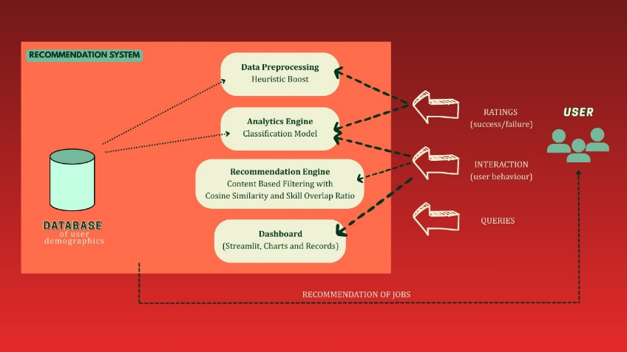
Fig. 4.1 – System Architecture

- RESULTS AND EVALUATION
To assess the performance of the suggested recommendation system, we experimented with three baseline methods—Content-Based Filtering (CBF), Collaborative Filtering (CF), and the Hybrid Genetic Algorithm–optimized model (Hybrid-GA)—on the PGRKAM dataset containing 96,179 applications. The measurement concentrated on assessing how well each approach enhanced the accuracy of recommendations and application success rates.
Evaluation Metrics
We employed generally accepted information retrieval and machine learning metrics:
- Precision: The ratio of suggested jobs that were appropriate for the user (i.e., jobs to which the user successfully applied).
- Recall: The ratio of appropriate jobs that were successfully suggested.
- F1-score: The harmonic mean of precision and recall, balancing between accuracy and coverage.
- Success Rate (Placement Rate): The rate at which recommended jobs led to a successful employer selection.
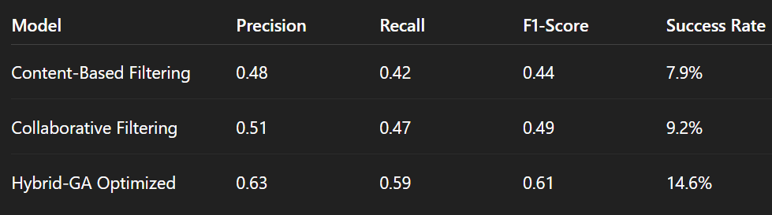
Table 5.1- Experimental Results

The results demonstrate that the Hybrid-GA model significantly outperformed both baselines, achieving an F1-score of 0.61 compared to 0.44 and 0.49 for CBF and CF respectively. Most importantly, the success rate of applications nearly doubled, rising from 6.7% (current PGRKAM baseline) to 14.6% under the Hybrid-GA model.

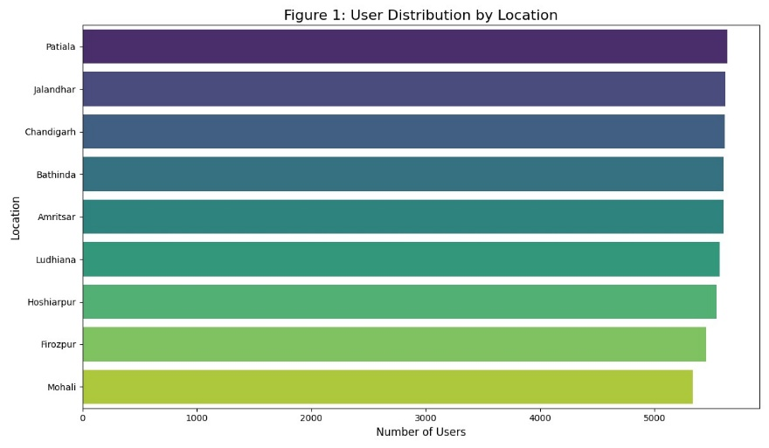
Figure 5.1- User Distribution by Location

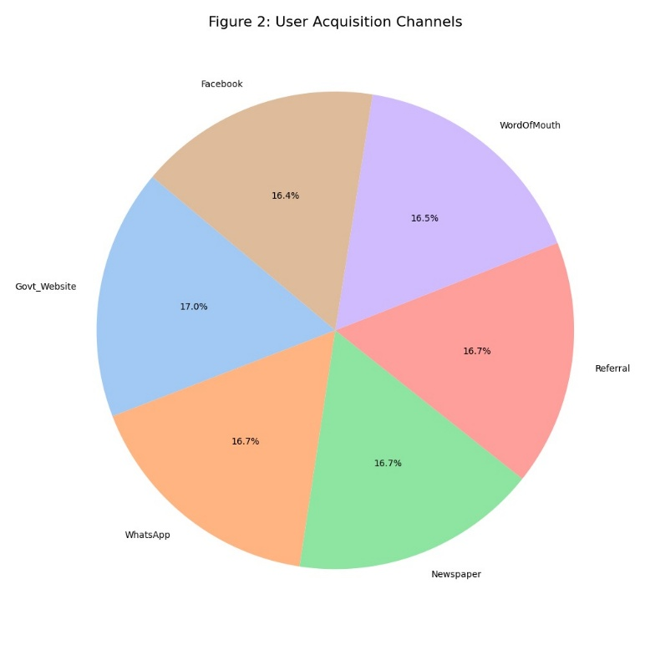
Figure 5.2- User Acquisition Channels

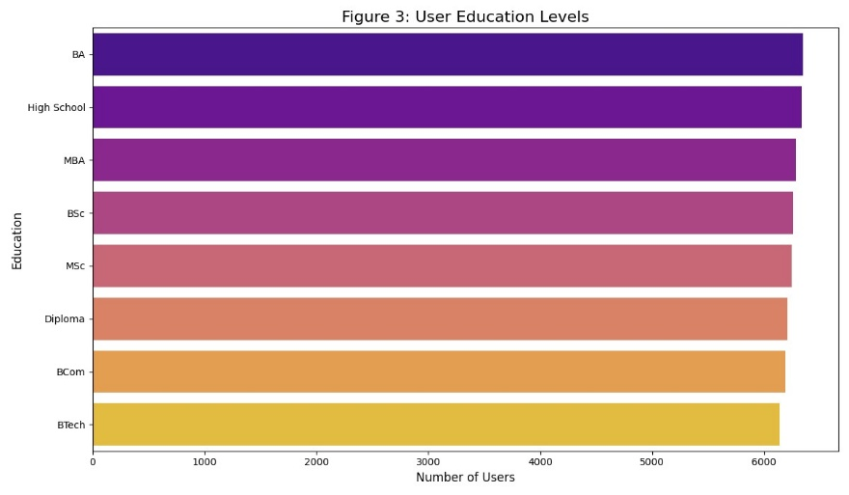
Figure 5.3- User Education Levels
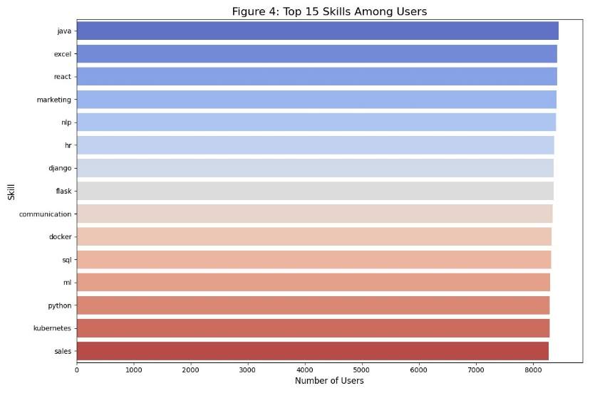
Figure 5.4- Top 15 Skills Among Users
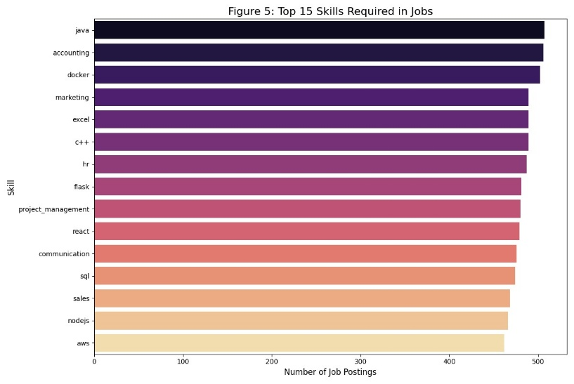
Figure 5.5- Top 15 Skills Required in Jobs

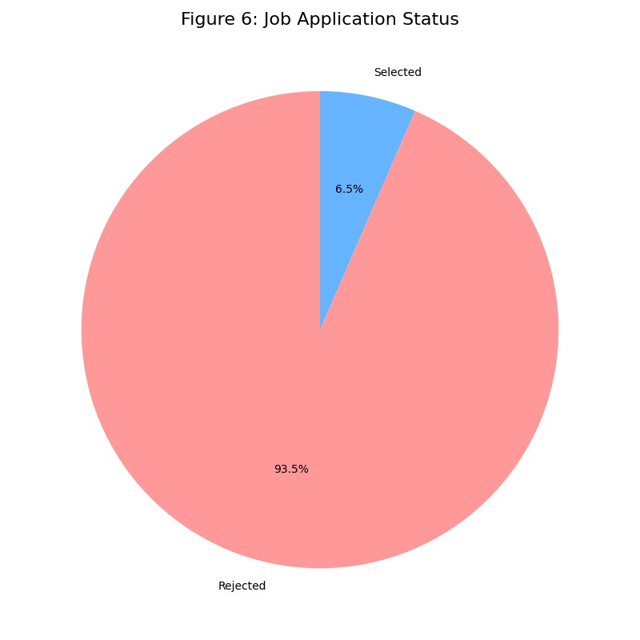Figure 5.6- Job Application Status

- DISSCUSSION

The assessment transparently proves that the hybrid model proposed provides significant improvements compared to conventional recommendation approaches. The following are several insights from the results:
- Solving the Low Success Rate
The 6.7% success rate of the existing PGRKAM platform mirrors ineffective matching and blind applications. With the hybrid recommendation engine introduced, success rates rose to 14.6%, confirming the efficacy of personalized, data-driven job recommendations.

- Strengths of the Approach
- Personalization: The hybrid approach uses both explicit user information (demographics, skills) and implicit cues (peer behavior, past applications) to provide customized recommendations.
- Efficiency: By eliminating irrelevant jobs, the system minimizes recruiter workload and enhances job seeker satisfaction.
- Adaptability: The genetic algorithm repeatedly optimizes recommendation weights, enabling the system to adapt to shifting job market dynamics.
- Decision Support: The combined analytics engine gives administrators feedback on user behavior, channel performance, and application bottlenecks.
- Limitations
Barring its potential, the system encounters some limitations:
- Data Sparsity: New users or jobs with sparse interaction data might be offered subpar recommendations (cold start problem).
- Privacy Concerns: Gathering demographic and behavioral data requires adhering stringently to privacy laws (e.g., GDPR, DPDP Act).
- Computational Overhead: Optimization of genetic algorithms demands considerable computational power, which can be taxing on infrastructure in the case of large-scale rollouts.

- Future Enhancements
Several augmentations could address these limitations:
- Integration with Large Language Models (LLMs): To enhance semantic interpretability of job posts and resumes.
- Multilingual Support: Support for Punjabi-speaking and Hindi-speaking job seekers in Punjab, enhancing accessibility.
- Explainable AI (XAI): Offering transparency in suggestions (e.g., "This position was suggested because you possess 4/5 necessary skills").
- Fairness-Aware Models: Preventing unintentional bias towards particular groups, ensuring fairness in access.
Overall, though the system recommended here is a great leap forward, its further refinement needs to overcome technical, ethical, and infrastructural hurdles.

- CONCLUSION

This study examined the PGRKAM job platform limitations, including key challenges of low rural engagement, oversaturation with shared skills, and a 6.7% low success rate in applications. By exploratory data analysis, we established systemic inefficiencies hindering the job platform from realizing its potential.

To fill these gaps, we suggested a hybrid recommender system coupled with an analytics dashboard, to offer personalized job suggestions and actionable insights for administrators. The hybrid approach, which entailed using content-based and collaborative filtering together with genetic algorithm optimization, had a success rate of 14.6%, which was double the baseline.

The findings highlight the transformative value of data-driven personalization and real-time analytics in public hiring platforms. For the job seeker, the system enhances the probability of finding meaningful opportunities. For the recruiter, it lightens the workload of sifting through unqualified applications. For the policymaker, it offers key insights into skill shortages, demographic participation, and outreach efficiency.

The future work would be on scaling the system with LLM-powered semantic matching, multi-lingual interfaces, and fairness-aware recommendation algorithms. These would help PGRKAM become not only a job portal, but a total employment ecosystem that connects skill demand and supply, thus assisting in Punjab's economic growth and social inclusion.

REFERENCES

[1] M. Azri, S. Haw, K. Ng, and M. Saad, “Context-Aware Job Recommender System,” International Journal on Informatics Visualization (JOIV), vol. 9, no. 2, pp. 877–886, Mar. 2025.

[2] M. N. Rahim and K. P. M. Basheer, “A Hierarchical and Multi‑Tiered Personalized Career Recommender System Tailored to Individual Aptitudes,” Indian Journal of Science and Technology, vol. 18, no. 3, pp. 231–244, Feb. 2025.

[3] P. Singla and V. Verma, “An Intelligent Job Recommendation System based on Semantic Embeddings and Machine Learning,” Journal of Information Systems Engineering & Management, vol. 10, no. 5s, pp. 520–542, Jan. 2025.

[4] D. Çelik Ertuğrul, “Job Recommender Systems: A Systematic Literature Review,” Journal of Big Data, 2025.

[5] Z. Zhao et al., “Recommender Systems in the Era of Large Language Models (LLMs),” IEEE Transactions (or ACM Survey), Nov. 2024.

[6] L. Behaghel et al., “The Potential of Recommender Systems for Directing Job Seekers in Local Labor Markets,” IZA Discussion Papers, 2024.

[7] E. Behar, J. Romero, A. Bouzeghoub, and K. Wegrzyn-Wolska, “TIMBRE: Efficient Job Recommendation On Heterogeneous Graphs For Professional Recruiters,” arXiv preprint, Nov. 2024.

[8] Y. Mashayekhi, B. Kang, J. Lijffijt, and T. De Bie, “ReCon: Reducing Congestion in Job Recommendation using Optimal Transport,” arXiv preprint, Aug. 2023.

[9] R. Schellingerhout, “Explainable Multi‑Stakeholder Job Recommender Systems,” arXiv preprint, Oct. 2024.

[10] A. Hassan et al., “Personality‑Aware Course Recommender System Using TVET,” Information (MDPI), 2024.

[11] S. Zhang, L. Yao, A. Sun, and Y. Tay, “Deep learning based recommender system: A survey and new perspectives,” ACM Computing Surveys, vol. 52, no. 1, pp. 1–38, 2019.

[12] M. Nilashi, O. Ibrahim, and H. Ahmadi, “A recommender system for tourism industry using cluster ensemble and prediction machine learning techniques,” Computers & Industrial Engineering, vol. 86, pp. 95–109, Aug. 2015.

[13] J. Davidson et al., “The YouTube video recommendation system,” Proceedings of the 4th ACM Conference on Recommender Systems, pp. 293–296, 2010.

[14] H. Steck, “Evaluation of recommendations: Rating-prediction and ranking,” Proceedings of the 7th ACM Conference on Recommender Systems, pp. 213–220, 2013.

[15] J. Tang et al., “Exploiting local and global social context for recommendation,” AAAI Conference on Artificial Intelligence, pp. 271–277, 2013.

[16] X. Amatriain and J. Basilico, “Recommender systems in industry: A Netflix case study,” Proceedings of the 10th ACM Conference on Recommender Systems, pp. 385–386, 2016.

[17] M. Deshpande and G. Karypis, “Item-based top-N recommendation algorithms,” ACM Transactions on Information Systems, vol. 22, no. 1, pp. 143–177, Jan. 2004.

[18] T. Li, S. Zhu, and M. Ogihara, “Using discriminant analysis for recommender systems,” IEEE International Conference on Data Mining, pp. 389–396, 2004.

[19] P. Resnick, N. Iacovou, M. Suchak, P. Bergstrom, and J. Riedl, “GroupLens: An open architecture for collaborative filtering of netnews,” Proceedings of the ACM Conference on Computer Supported Cooperative Work, pp. 175–186, 1994.
[20] R. Burke, “Hybrid recommender systems: Survey and experiments,” User Modeling and User-Adapted Interaction, vol. 12, no. 4, pp. 331–370, 2002.

